CUSTOM ORDER CHECK LIST; |  |  |  |  |  | TEAM NAME: |  |  | Revive
1. Check your size…..
http://www.tineli.com.au/custom-cycling-clothing/size-guide.php
2. Pay for your order: Acc Name. A Edwards, BSB 084901, Acc.No. 562847545
3. Email anouska@revivestudio.com.au with your receipt of payment and kit order/size
4. Wait with anticipation to be the coolest kid on the block!
ORDER |  | PRICE | 128 | 140 | 152 | XS | S | M | L | XL | XXL | 3XL | 4XL | 5XL | TOT
ITEM DETAIL:
s/s Jersey Race Men's |  | $80
s/s Jersey Race Wmn's |  | $80
s/s Jersey AERO |  | $102
Standard length - 2.5 cm |  | $102
Slightly longer - 5.0 cm |  | $102
Bibshorts Men's |  | $80
Bibshorts Men's pro tour cut (long niks) |  | $80
Bibshorts Wmn's |  | $80
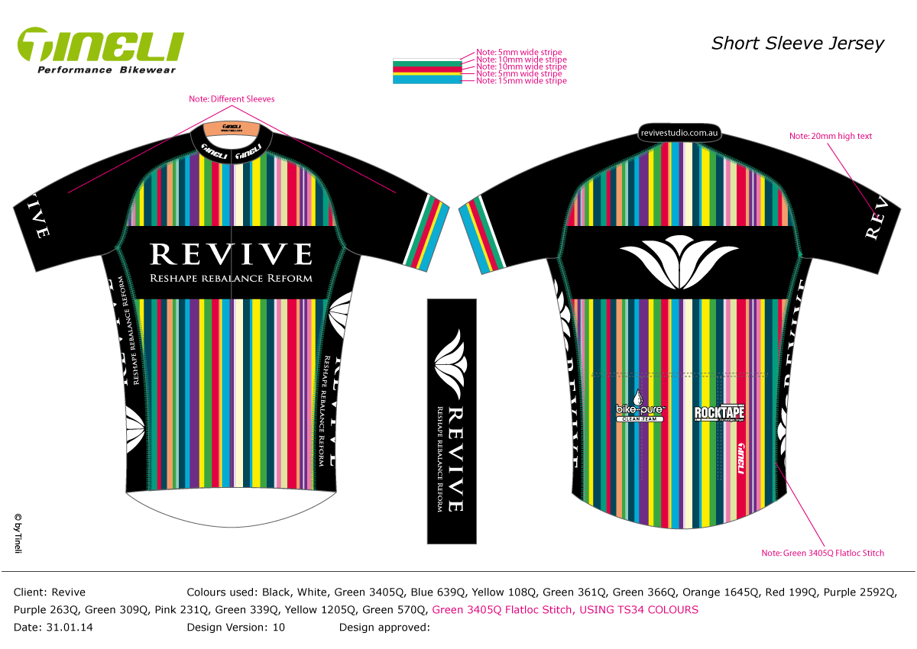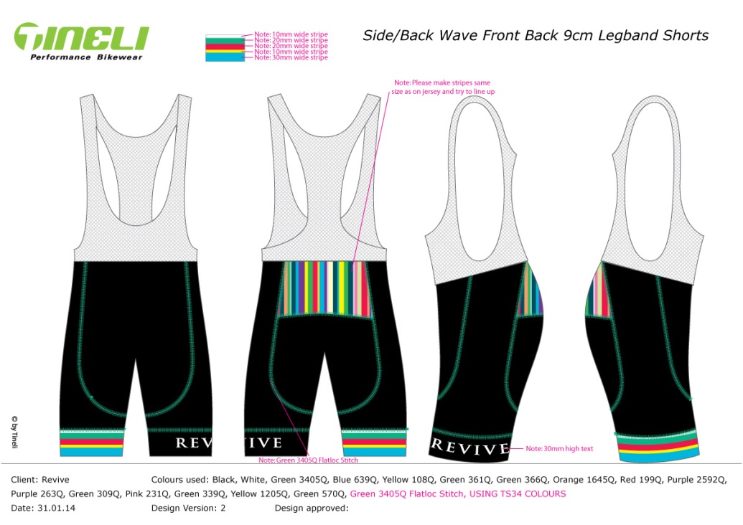

ORDER FORM DUE: 28th February or asap

