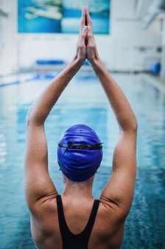 **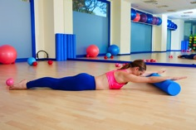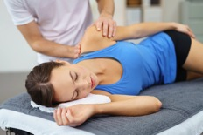

**No. 3: Exercise improves mood**

Need an emotional lift? Or need to blow off some steam after a stressful day? A workout at the gym or a brisk 30-minute walk can help. Physical activity stimulates various brain chemicals that may leave you feeling happier and more relaxed. You may also feel better about your appearance and yourself when you exercise regularly, which can boost your confidence and improve your self-esteem.

**No. 4: Exercise boosts energy**

Winded by grocery shopping or household chores? Regular physical activity can improve your muscle strength and boost your endurance. Exercise and physical activity deliver oxygen and nutrients to your tissues and help your cardiovascular system work more efficiently. And when your heart and lungs work more efficiently, you have more energy to go about your daily chores.

**No. 5: Exercise promotes better sleep**

Struggling to fall asleep? Or to stay asleep? Regular physical activity can help you fall asleep faster and deepen your sleep. Just don't exercise too close to bedtime, or you may be too energized to fall asleep.

**5 REASONS TO EXERCISE FOR WELLNESS**

The body of evidence continues to grow to show the myriad of health benefits of exercise. Exercise can come in many different forms and intensities and there are so many different ways you can move your body and reap the health beneftis of movement and exercise. Here is some information from the Mayo Clinic:

**No. 1: Exercise controls weight**

Exercise can help prevent excess weight gain or help maintain weight loss. When you engage in physical activity, you burn calories. The more intense the activity, the more calories you burn. You don't need to set aside large chunks of time for exercise to reap weight-loss benefits. If you can't do an actual workout, get more active throughout the day in simple ways — by taking the stairs instead of the elevator or revving up your household chores.

**No. 2: Exercise combats health conditions and diseases**

Worried about heart disease? Hoping to prevent high blood pressure? No matter what your current weight, being active boosts high-density lipoprotein (HDL), or "good," cholesterol and decreases unhealthy triglycerides. This one-two punch keeps your blood flowing smoothly, which decreases your risk of cardiovascular diseases. In fact, regular physical activity can help you prevent or manage a wide range of health problems and concerns, including stroke, metabolic syndrome, type 2 diabetes, depression, certain types of cancer, arthritis , osteoporosis and falls.

Page 4

Meet our Client of the month………

Page 3

Exercise and sleep – what’s the connection?

Page 2

Check out our August specials

August NEWSLETTER 2016 EXERCISE FOR WELLNESS

.

Julie Campbell

Managing Director Revive Ashgrove

Editorial

Can’t believe it’s August! My birthday is at the end of this month and I’ve always thought that signals the end of most of the year – where oh where has this year gone? This month we are looking at some of the many benefits of regular exercise – from preventing osteoporosis to conditioning for elite athletes, exercise can take many shapes and forms – the most important thing is that you have some of it in your routine. The research continues to mount to show exercise can help prevent cancer, reduce stress, improve our sleep and it goes on and on….. there’s always something else to do and lots of ways to procrastinate and not exercise – the challenge is to find something you enjoy that can become a lifelong habit as you really can’t afford to not exercise! So get to it and start enjoying the increased energy and vitality you will have once you start. We’re here to guide and assist you on your exercise journey so if you need a hand deciding what’s the best form of exercise for you come and have a chat and we can steer you in the right direction – have a wonderful month –

Jules

**Did you know…?**

**Your tongue is the only muscle in your body that is attached only at one end**

**Your heart rests between each beat – over a normal life span your heart stands still for about 20 years**

**The human nervous system can relay messages to the brain of speeds of up to 200 miles per hour**

AUGUST SPECIALS

**MASSAGE**

5 one hour massages with Catalina

$300

**MAT PILATES**

Mat start up pack – intro mat plus 5 mat classes

$100 (save $40)

40 mat pilates pack $480 ($12 per class , save $7 per class)

Also

Purchase a 20 or 30 mat class in August and receive a free INTRO reformer class or a free half hour massage

**YOUNG AT HEART REFORMER**

10 pack of YAH - $200 (worth $300)

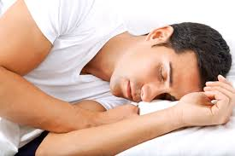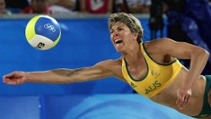

Exercise and Sleep

Veronica Balen

Ever find yourself wide awake at 2:00 am frustrated that you’re not getting the sleep your body needs? After all, you were exhausted in your 3pm meeting, so why on Earth do you feel like you could get up and spring clean the house now?

Research shows that a single exercise session is enough to reduce the time taken to fall asleep and increases the duration of sleep for that night. Furthermore, commencement of a regular exercise regime has found sleep improvements in adults who suffer from insomnia after only 4 weeks. And you don’t have to be attending boot camp classes to reap the benefits. In fact, moderately intense exercise has been found to be more beneficial than vigorous exercise when it comes to improving our quality of sleep.

So if you’re fed up with counting sheep in the wee hours of the morning, then try adding in an additional exercise session (or three!) a week. Happy snoozing!

The only time you should ever look back is to see how far you’ve come !

The role of Pilates in the Elite Athlete

Veronica Balen

Revive Physiotherapist

With the Olympics just around the corner it’s not hard to understand that exercise and elite athletes go hand in hand. Watching the muscular thighs of the sprinters during the 100m dash is a sure fire way to remind ourselves that these high level athletes train hard and train A LOT. We all know that athletes train specifically for their chosen sport: runners run, cyclists cycle and the synchronised swimmers do whatever it is they do in their fabulous caps. But outside of all of that, just how important is it for elite athletes to stop and take the time out to specifically work on their core?

VERY

Our core muscles act as the building blocks of our muscular system. Think of these muscles as playing the same role as the foundations for a house. No matter how grand and flashy the house looks on the outside, if it has an unstable and weak foundation, it’s going to run into all sorts of problems. The same goes for our bodies. While it might look nice to have big beautiful muscles on the outside, (cue six pack please), it is not always indicative of a great core.

Practicing regular core exercises, like Pilates, is an imperative part of the elite athletes training regime. It focuses on improving spinal mobility and muscles flexibility, while building strength and endurance of stabilising muscles.

Many athletes train the same action over and over (just think of a discus thrower or a shot putter as examples) and are no doubt at an increased risk of overuse injuries. Pilates helps re-train motor patterns so to allow optimal functional movement and better support to structures when they are put under high demand. This type of training specifically helps in injury prevention and allows the athletes to continue their training uninterrupted as a result of unplanned niggles.

While core strengthening improves overall function and well being in us mere mortals, for the elite athlete it is an essential training method to enhancing performance and may very well be the difference between making it onto the podium or not.

See you in Rio!

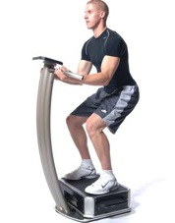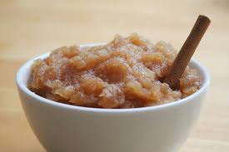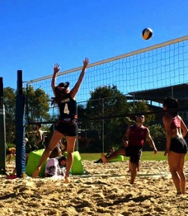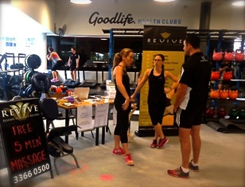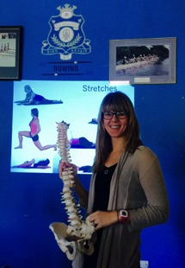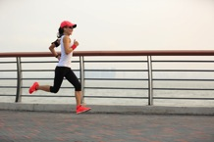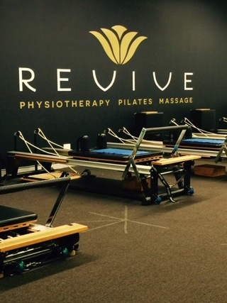

The Galileo is a total body vibration machine which makes your muscles contract at 30-50 Hz.

It offers substantial strengthening, speed and explosive power benefits in a short period of time without placing high loads on the tendons and joints. It can be used as a stand alone form of exercise instead of a weights program or circuit class, or in conjunction with regular strengthen training.

15 minutes is equal to 90min in the gym!

Training sessions of only 2-3 minutes twice a week produce measurable effects.

Many studies show that vibrations at the right dose can lead to faster growth and recovery of all tissues.

Galileo training improves power and balance, reduces low back pain, enhances blood flow significantly, improves bone quality, prevents loss of tissue quantity and quality (muscle, bone, tendons

At Revive we offer training sessions in this amasing machine that is not only very effective but time saving.

WE HAVE PACKAGES AVAILABLE IN HALF HOUR SPOTS - ENQUIRE NOW

WHOLE BODY VIBRATION TRAINING – WHAT’S THE BUZ?

From our local Naturopath - Ananda Mahony

**Support for the pain of IBS**

Irritable bowel syndrome (IBS) can present with diarrhoea, abdominal pain and accelerated transit time. The bloating, stress response and inflammation that commonly result can cause pain sensations which become chronic. Research has shown that changes in the intestinal microbiota (bacteria in the gut) are linked with intestinal inflammation in IBS and have been found to influence overall severity and related pain via numerous mechanisms including immune activation, higher frequency of messages send to the brain (interpreted as pain) and increased stress responses.

Diet, in particular can have a significant influence on IBS, the composition of the gut microbiota and also influence individual experiences of pain. One way of influencing IBS severity is to change the make-up of bacteria in the gut, creating a microbial environment that promotes the growth of healthy bacteria. Patients with IBS often report improvement with specific diets and the consumption of specific types of dietary fibre that commensal bacteria ‘feed’ on can minimise the overgrowth of pro-inflammatory bacteria and as such may help to reduce symptoms. Please note however, not all fibres confer this benefit and some can worsen symptoms.

One example of a ‘gut-friendly’ fibre recipe is Healing Stewed Apple. Consumed daily it can support the health of the microbiome, help reduce local inflammation and support gut function.

**Healing Stewed Apple**

**Ingredients**

* 6 cooking apples (Avoid sweet apples like Pink Lady. Choose Granny Smith, Gala or other cooking apple as desired)
* 1/2 cup water
* 2 tsp. cinnamon
* ½ cup of sultanas (optional)

**Directions**

Peel and core the apples and chop them into small evenly sized pieces.

Put all the ingredients in a covered, heavy-bottomed pan and cook for about 15 minutes, stirring regularly. Cook until soft with rough shapes, no longer identifiable as apple slices. The colour should be a russet brown with the cinnamon effect.

You can also double or treble the quantities if you want to make a larger batch as this will store in the fridge for up to 10 days.

**Dose**

Eat two large dessert spoons daily.

***Author: Ananda Mahony***

*B.App.SC (Naturopathy), Grad. Cert. The Science of Medicine (Pain Management).*

*Integrated Pain Management, Chronic Skin Conditions, Wellbeing.*

Our new REFORMER STUDIO is almost finished. We are planning on redoing the floors with a timber look lino to lighten the space and complement the wood in the equipment.

There are lots of new class times available for our reformer clients. Once you have done your initial reformer intro session you can book on line here:

*https://clients.mindbodyonline.com/classic/admhome?studioid=33409*

CLIENT OF THE MONTH

NICOLE QUIRK

I have had the most wonderful experience with everyone at Revive! I have been to so many physios and massage therapists regarding my back pain and scoliosis and Revive is the only place that has truly helped me manage these issues.

So once I started to get knee pain I knew that we would be able to manage that as well!

Managing all this pain I have been able to progress in keeping fit by attending pilates and fit to run classes. These classes have been amazing and I enjoy every second of them! All of the staff have been so friendly and they make you feel so comfortable while your there.

I am so much happier and more comfortable than I have been in so many years. I have seriously enjoyed every

appointment I have had at Revive whether it be physio, massage, pilates, or fit to run!

Nicole

Congratulations Nicole – enjoy your massage